Name: Ali Albayrak

Student Id: P304320

Movies Project Test Documentation

Provide a test documentation

o Test your code against the PEAR code standard with an appropriate static analysis tool, e.g. Code Sniffer

o Test with sample inputs with screenshots. Include testing in various browsers, Chrome and Firefox.

o Provide an evidence that you adjusted your application base on the test.

PEAR code standard with Code Sniffer:

Before Fix:

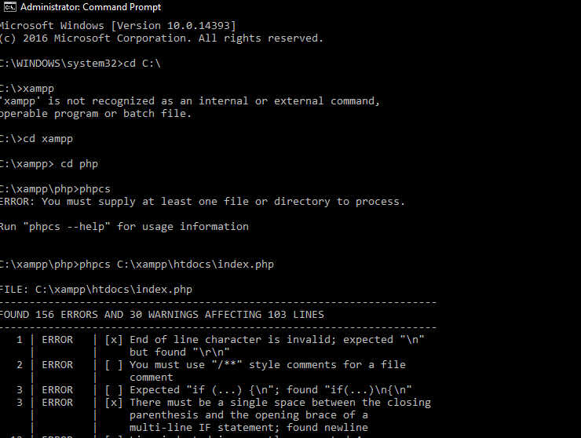

After Fix:

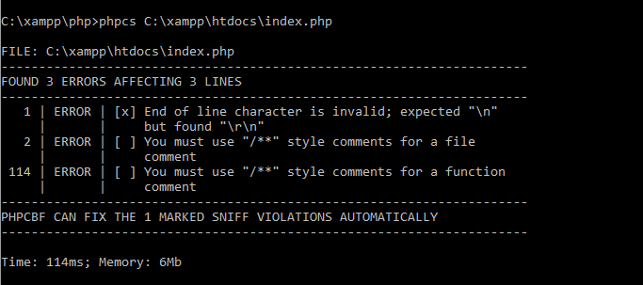

Test Table:

|  |  |  |  |  |
| --- | --- | --- | --- | --- |
| Test No | Search by Title | Search by Genre | Search by Rating | Search by Year |
| 1 | Adventures | - | - | - |
| 2 | Adventures | Comedy | - | - |
| 3 | Adventures | Family | G | - |
| 4 | - | Drama | - | - |
| 5 | - | Comedy | PG-13 | - |
| 6 | - | - | NR | 1951 |
| 7 | - | - | - | 1990 |
| 8 | - | Music | - | - |
| 9 | - | - | UNK | - |
| 10 | Always | Drama | PG | 1989 |

Test No 1:

Chrome:

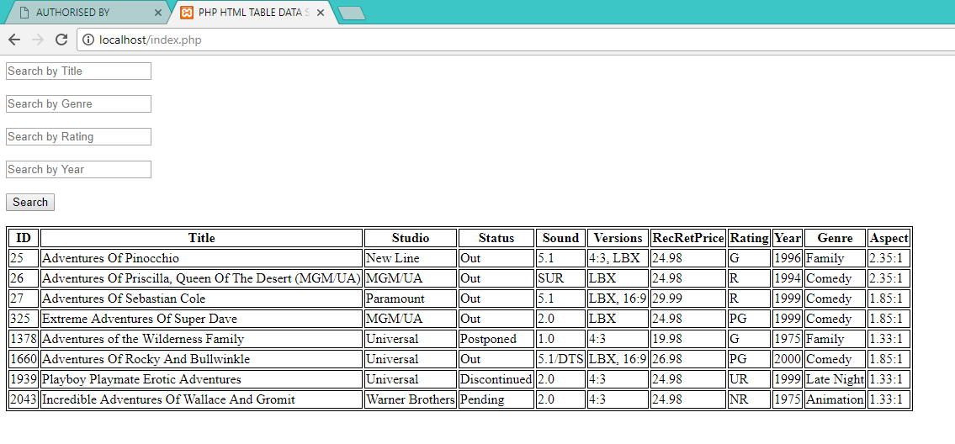

Firefox:

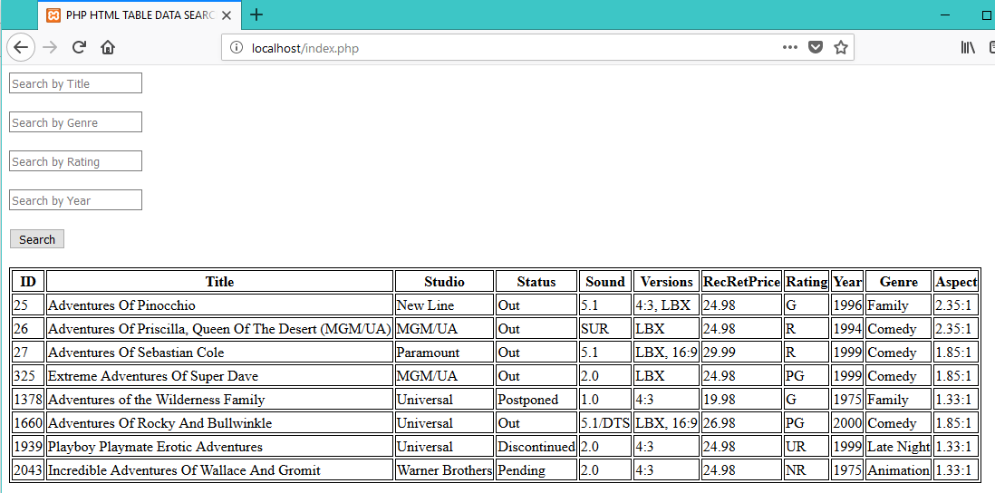

Test No 2:

Chrome:

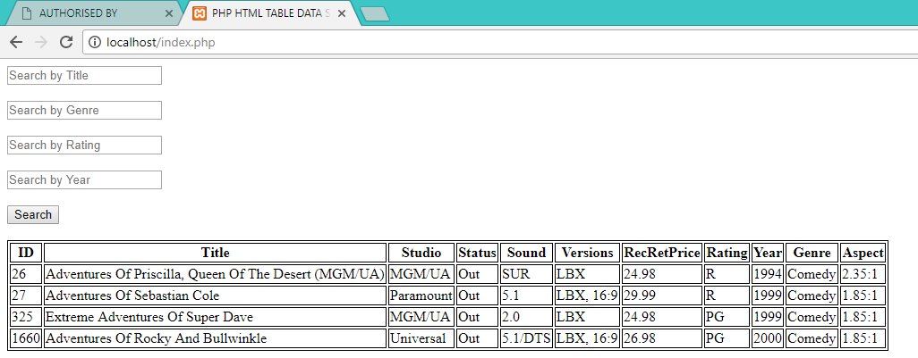

Firefox:

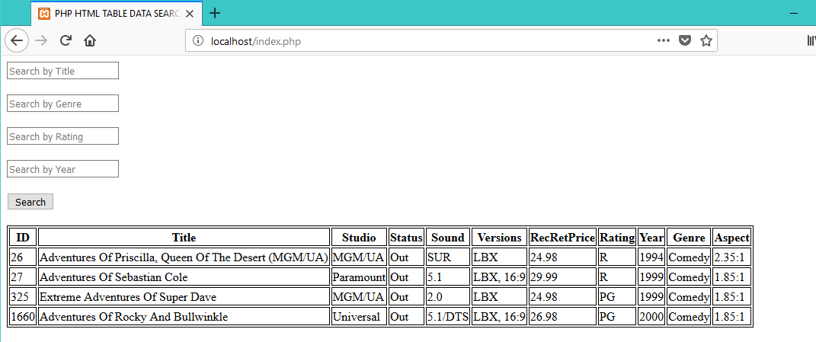

Test No 3:

Chrome:

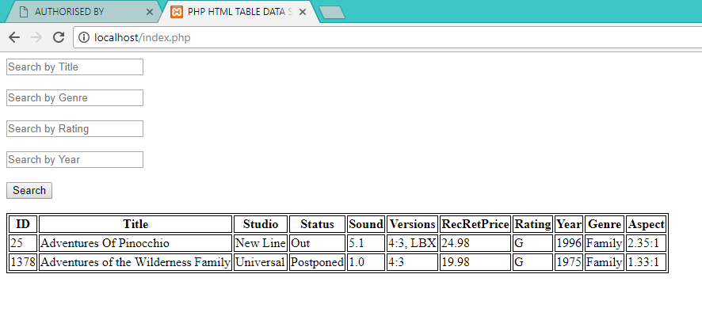

Mozilla:

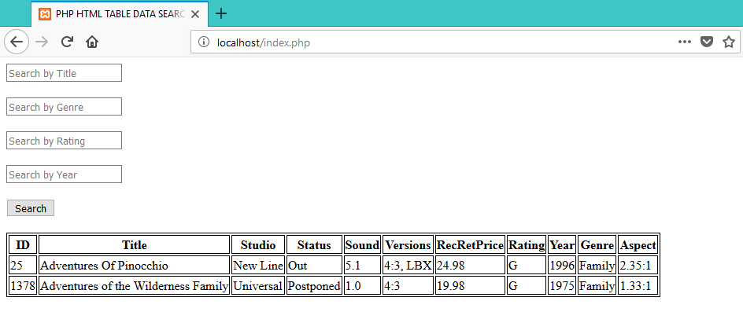

Test No 4:

Chrome:

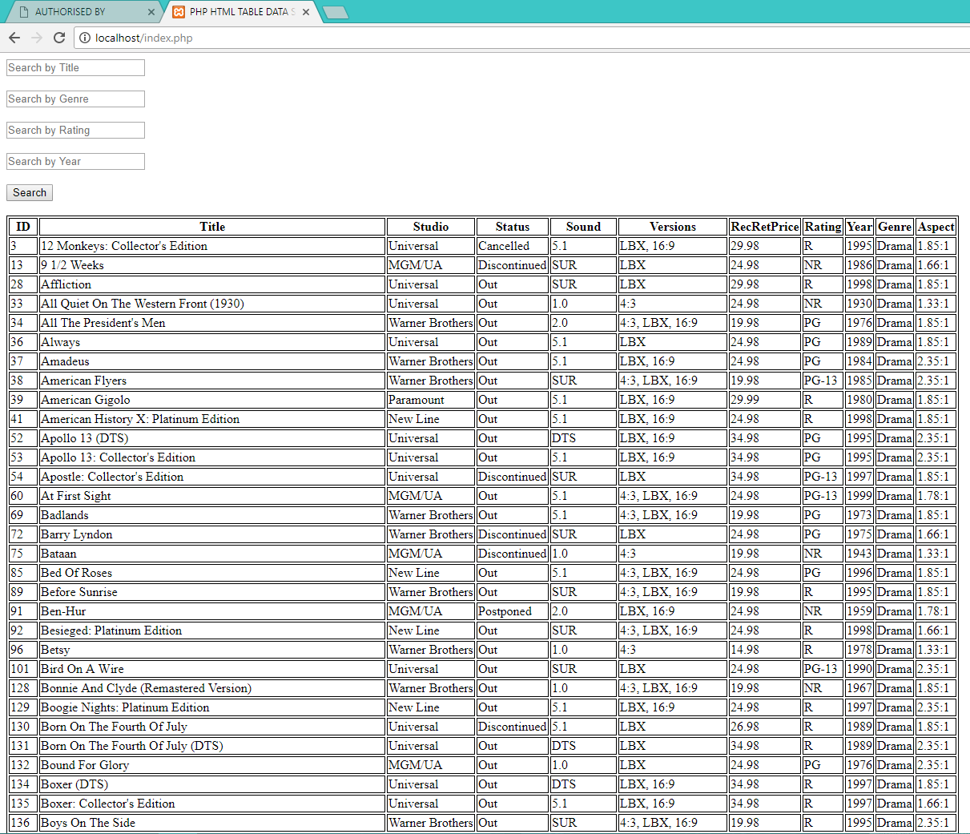

Firefox:

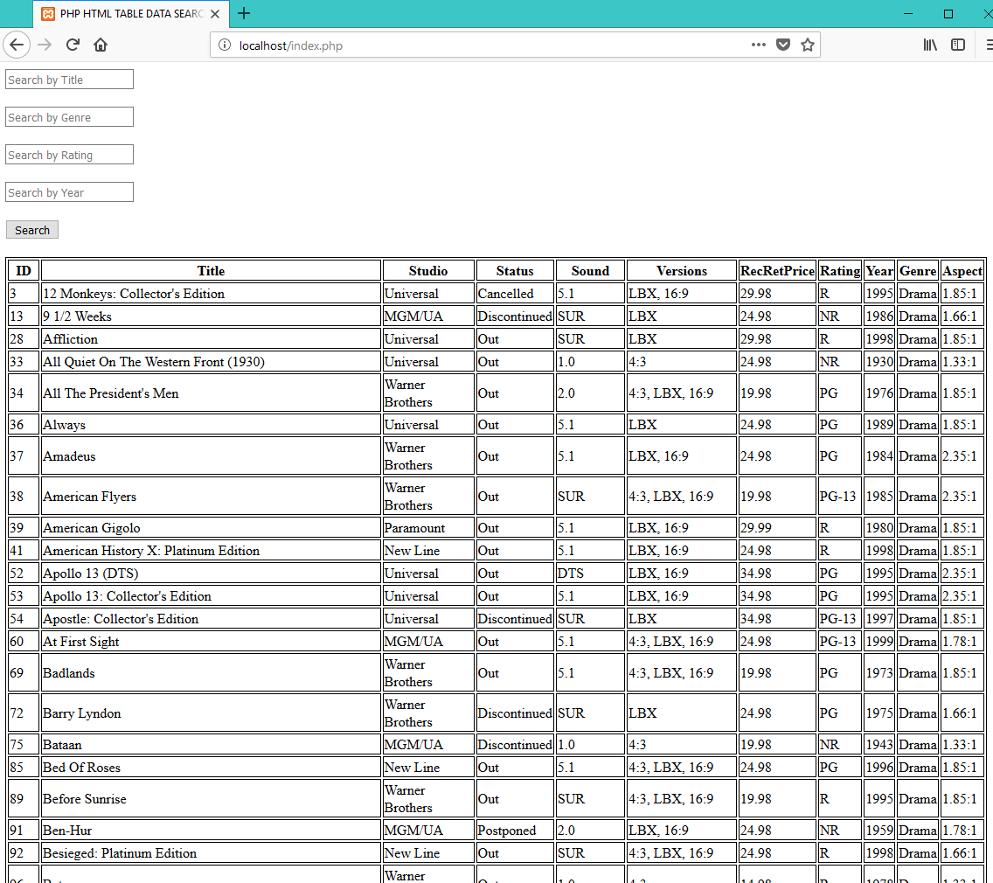

Test No 5:

Chrome:

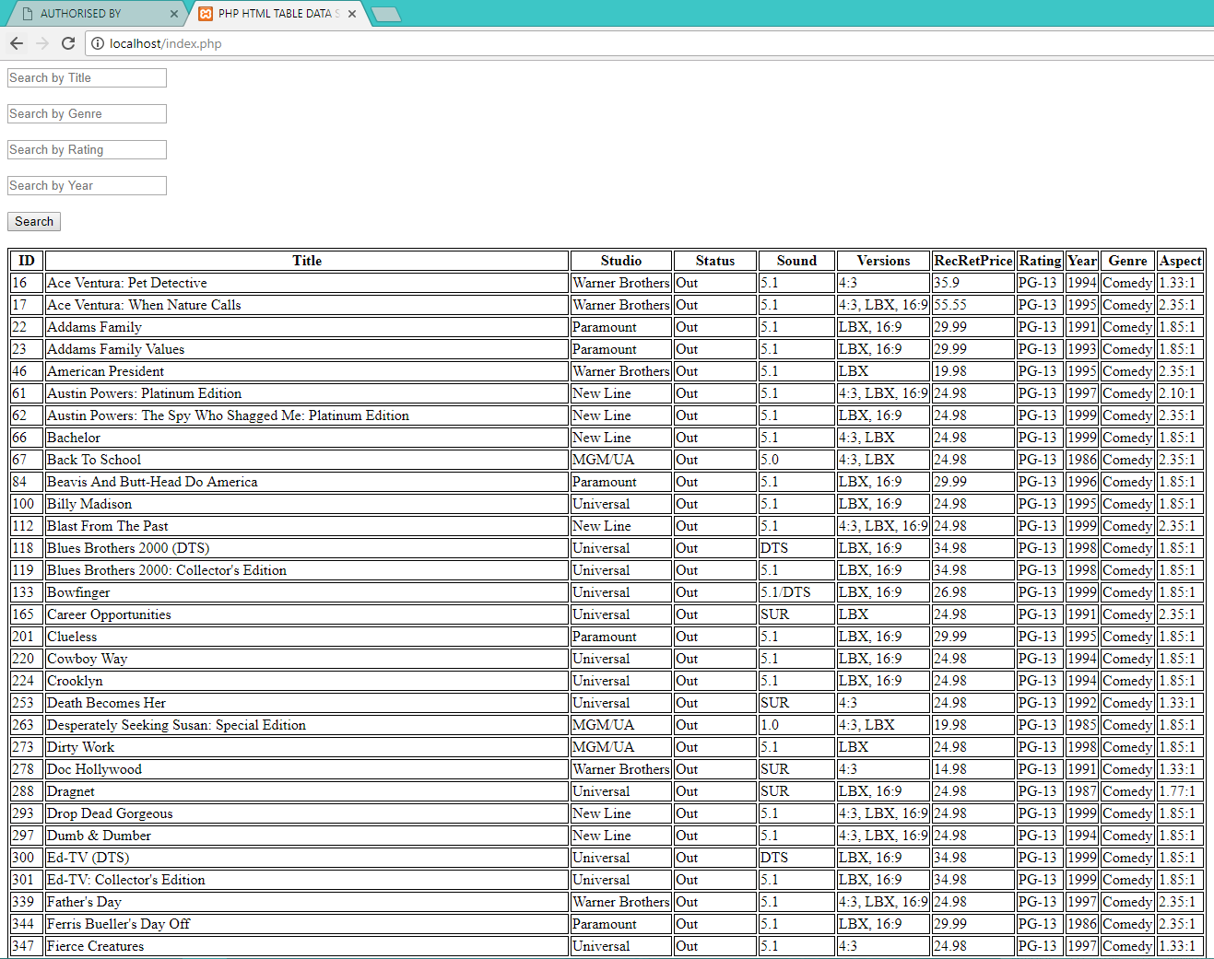

Firefox:

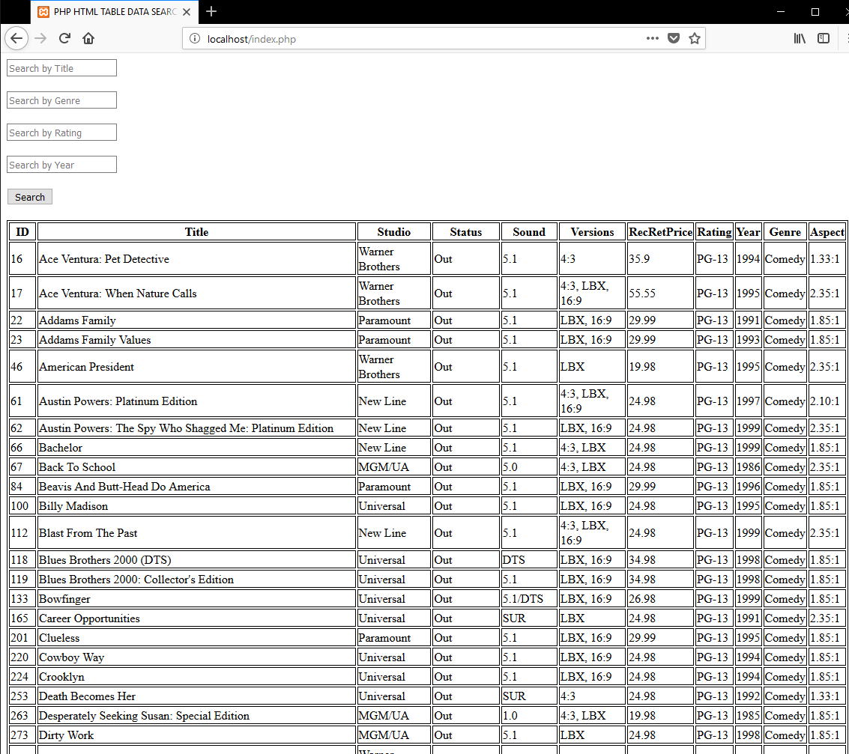

Test No 6:

Chrome:

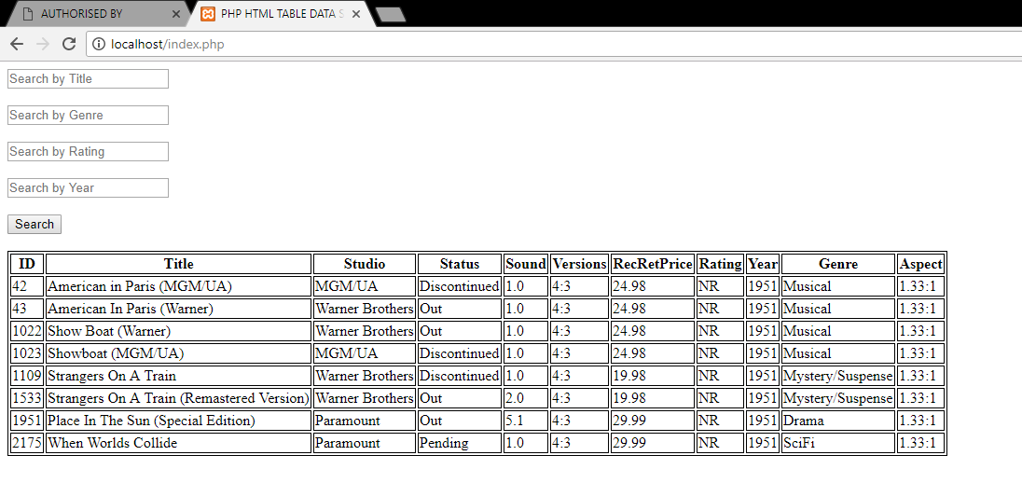

Firefox:

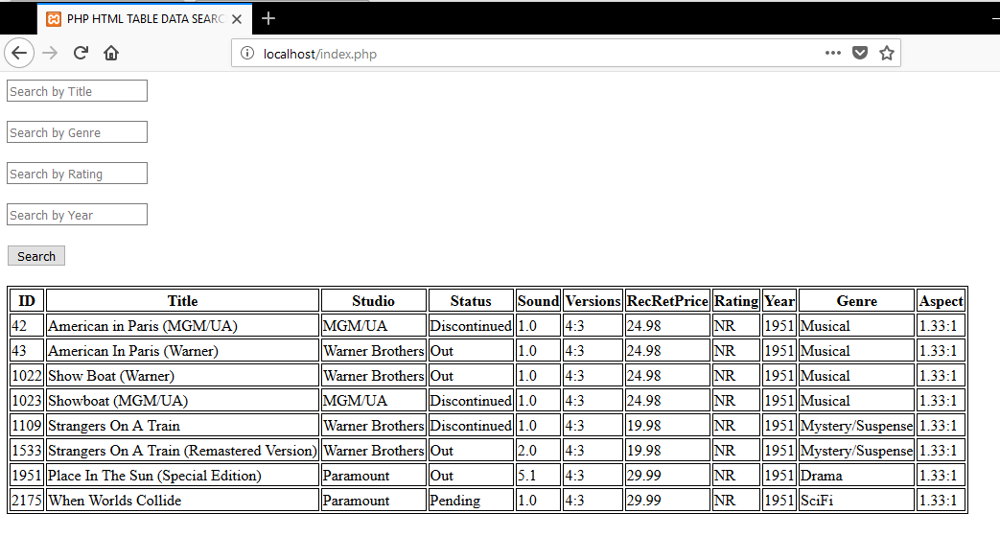

Test No 7:

Chrome:

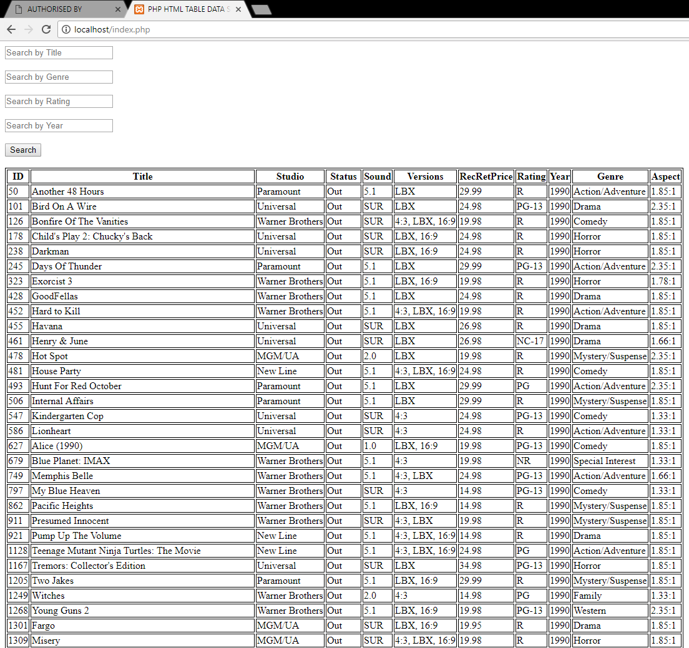

Firefox:

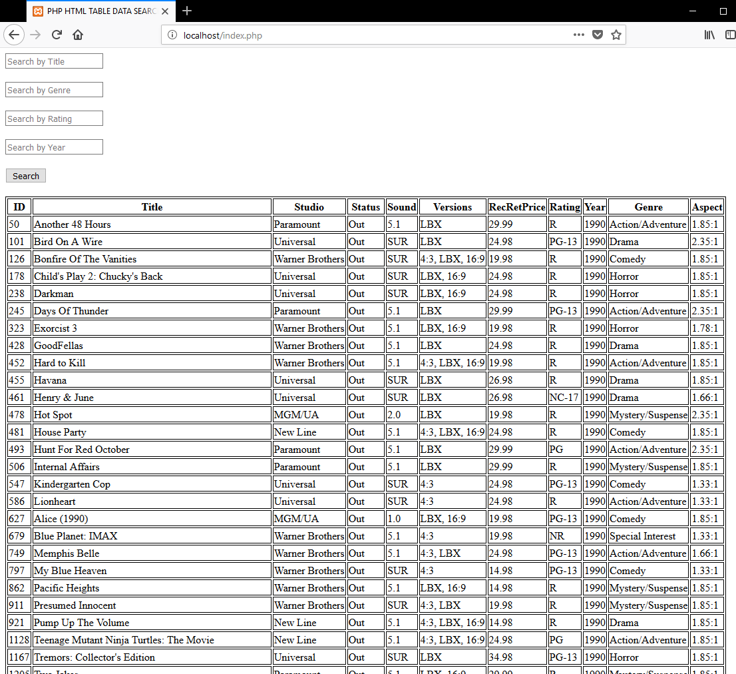

Test No 8:

Chrome:

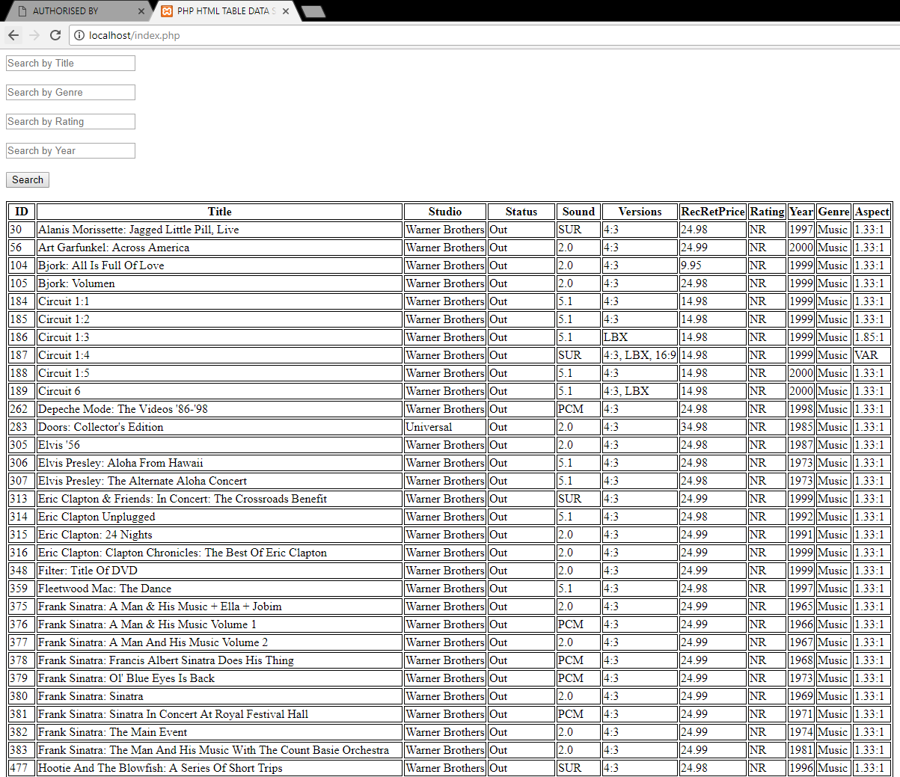

Firefox:

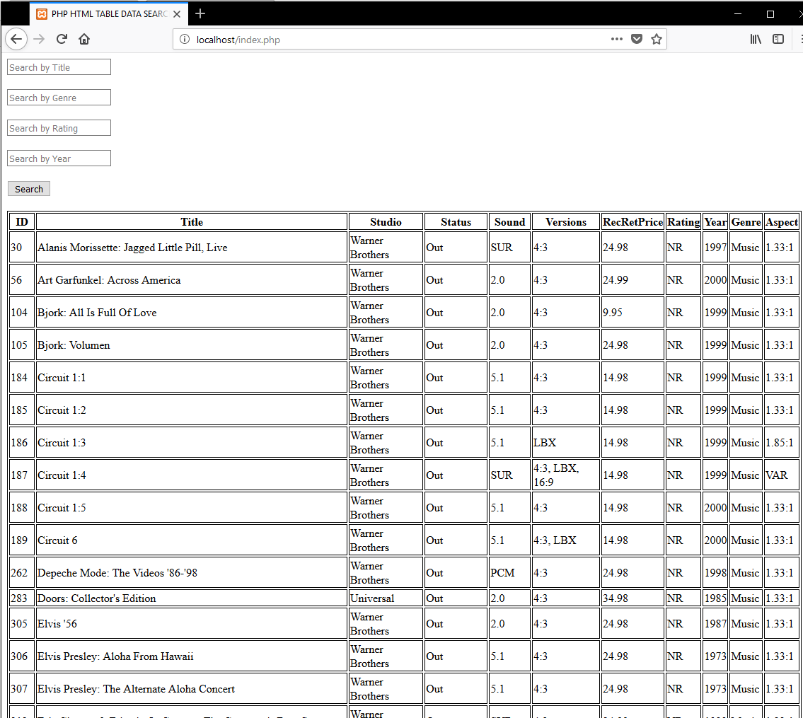

Test No 9:

Chrome:

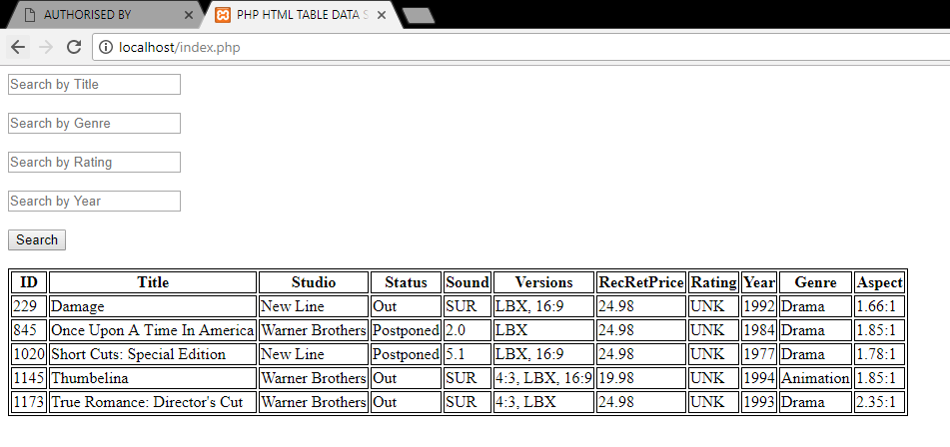

Firefox:

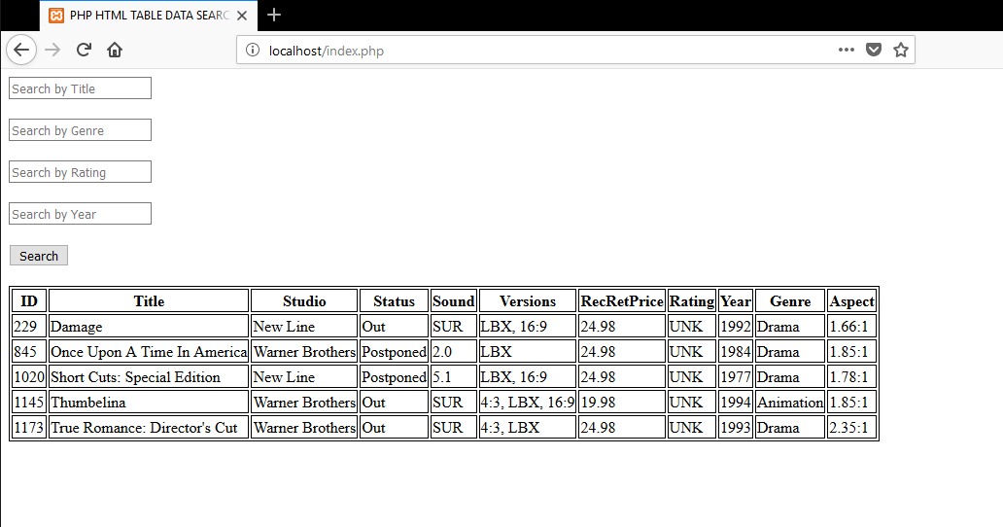

Test No 10:

Chrome:

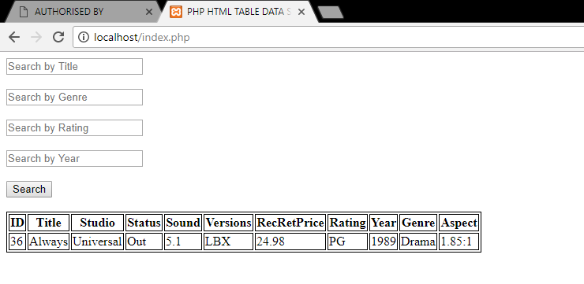

Firefox:

